“Київський фаховий коледж зв’язку”

Циклова комісія Комп’ютерної інженерії

**ЗВІТ ПО ВИКОНАННЮ**

**ЛАБОРАТОРНОЇ РОБОТИ №7**

з дисципліни: «Операційні системи»

**Тема: “Створення скриптових сценаріїв та визначення апаратної конфігурації системи”**

Виконали студенти

групи КСМ-13а

Команда “Viper”:

Малієнко А. М.,

Мішин А. О.

та Нерощин Д.О.

Перевірив викладач

Сушанова В.С.

Київ 2023

**Мета роботи:**

**1. Отримання практичних навиків роботи з командною оболонкою Bash.**

**2. Знайомство знайомство з базовими діями при роботі зі скриптовими сценаріями.**

**Матеріальне забезпечення занять**

**1. ЕОМ типу IBM PC.**

**2. ОС сімейства Windows (Windows 7).**

**3. Віртуальна машина – Virtual Box (Oracle).**

**4. Операційна система GNU/Linux – CentOS.**

**5. Сайт мережевої академії Cisco netacad.com та його онлайн курси по Linux**

***Готувала матеріал студентка Малієнко А.***

***Завдання для попередньої підготовки.***

***1. Прочитайте короткі теоретичні відомості до лабораторної роботи та зробіть невеликий словник***

***базових англійських термінів з питань призначення команд та їх параметрів.***

***2. Вивчіть матеріали онлайн-курсу академії Cisco “NDG Linux Essentials”:***

***- Chapter 11 - Basic Scripting***

***- Chapter 12 - Understanding Computer Hardware***

***3. Пройдіть тестування у курсі NDG Linux Essentials за такими темами:***

***- Chapter 11 Exam***

***- Chapter 12 Exam***

***4. На базі розглянутого матеріалу дайте відповіді на наступні питання:***

***4.1. Охарактеризуйте поняття скриптового сценарію у командній оболонці.***

A shell script is a simple text file containing a set of commands to be executed in the operating system shell. Scripting allows you to automate various tasks using a scripting language such as Bash, sh, or others.

The key features of scripting are:

-Command execution: You can list any command supported by the shell in the script, one after the other.

-Access to functional programs: Scripts have access to all commands and possible command combinations, including conditional statements, loops, and changes.

-Task automation: Scripts are used to automate repetitive or routine tasks, which saves a lot of time for the user.

-Use of variables: Scripts can use variables to store and manipulate data.

-Conditional statements: Scripts can make decisions based on conditions and perform actions accordingly.

-Loops: Scripts can perform the same actions multiple times using loops.

-Parameters and arguments: Scripts can use parameters and arguments to modify behavior at runtime.

Scripting is widely used to automate system administration, file processing, software deployment, and many other tasks in the operating system shell. It demonstrates convenience and performance in working with Linux and other systems that support command-line programming.

***4.2. Яким чином створюються та редагуються скрипти, що треба зробити щоб запустити скрипт?***

Choose a Text Editor (Notepad, Sublime Text or Visual Studio Code), then open it and write your script, which is a set of instructions written in the selected programming language. Save the script with the appropriate file extension for the language you're using (Python — "py", JavaScript — ".js"). Open your command prompt or terminal, navigate to the directory where your script is saved, and run it by typing the appropriate command (Python — "python script.py").

***4.3. Які основні компоненти материнської плати ви знаєте?***

Central Processing Unit (CPU), Chipset, RAM Slots, CPU Sockets and Cooling Connectors, Expansion Slots (PCIe, PCI, and others), Input/Output Ports (I/O ports), CMOS Battery, BIOS/UEFI Chip (Basic Input/Output System/Unified Extensible Firmware Interface), Power Connector, Sound Chips and Network Controllers.

***4.4. Коротко охарактеризуйте для яких пристроїв оперують поняттями MBR та GPT?***

In MBR, you can create up to four primary partitions, and if that's not enough for the user, you can divide partitions into logical ones. For example, you can store Windows 10 files in one partition and use another logical partition of the SSD for Linux or Windows 7.

In a modern GPT solution, there are no such limitations, and you have many more possibilities. You can partition an SSD in any way you like. You can create 128 separate sectors, eliminating the need for logical partitions. And this 128 limit is only for Microsoft OS; other OSs don't have this limitation.

In reality, it's logical that a more modern solution will always outperform the outdated one, as shown by the comparison – GPT is better. The new standard works very well with large-capacity SSDs in laptops or computers. GPT has also shown great reliability, as it is resilient to data corruption during failures. Even in case of a failure, everything can be quickly and easily restored. In general, for new and fast SSDs, GPT is a more preferable choice. It fully unleashes the potential of solid-state drives, allowing for speedy system boot times. However, there are nuances with other operating systems.

If you are installing an old OS, it's better to choose the old but reliable MBR, as it still serves its purpose. Many PC users still use Windows XP to this day. Although it's not recommended to use this OS on an SSD, as it significantly shortens the drive's lifespan.

***4.5. В чому суть операції монтування, для чого вона потрібна?***

Mounting a file system is a system process that prepares a disk partition for use by the operating system.

The operation of mounting consists of several steps:

1Determining the type of file system being mounted.

2Checking the integrity of the file system being mounted.

3Reading system data structures and initializing the corresponding file system manager module (file system driver).

4Setting a flag indicating the completion of the mounting process. When the file system is correctly unmounted, this flag is cleared. If the system detects at boot that the flag hasn't been cleared, it means the operation was not completed correctly, and the file system may require repair.

5Integrating the new file system into the overall namespace.

***5. Підготувати в електронному вигляді початковий варіант звіту:***

***- Титульний аркуш, тема та мета роботи***

***- Словник термінів***

***- Відповіді на п.4.1 та п.4.5 з завдань для попередньої підготовки***

***Готував матеріал студент Мішин А.***

Progress

1. Initial work in CLI mode in Linux OS of the Linux family:

1.1. Start the VirtualBox virtual machine, select CentOS and run it. Log in

under user: CentOS, password for login: reverse (if you run LR in 401 aud.) and run

terminal.

1.2. Start the Ubuntu_PC virtual machine (if you are doing the LR tasks through the netacad academy)

1.3. Start your Linux family operating system (if you are working on your own PC and its

installed) and launch the terminal.

2. Work through all the command examples presented in the labs of the NDG Linux Essentials course -

Lab 11: Basic Scripting and Lab 12: Understanding Computer Hardware. Create a table to describe these

teams***

|  |  |
| --- | --- |
| Команда | Опис |
| echo "Hello, World!" | Print the line "Hello, World!" on the screen |
| touch file.txt | Create an empty file named file.txt. |
| ls | List the files and directories in the current directory. |
| ls -l | Display a detailed list of files and directories. |
| pwd | Display the current directory. |
| cd directory | Change the current directory to directory. |
| mkdir new_dir | Create a new directory with the name new_dir. |
| cp file.txt new_dir/ | Copy the file file.txt to the directory new_dir. |
| mv file.txt new_name.txt | Rename the file file.txt to new_name.txt. |
| rm file.txt | Delete file.txt file. |
| chmod +x script.sh | Grant rights to execute the script script.sh. |
| ./script.sh | Run the script script.sh. |
| nano file.txt | Open the file.txt file for editing in the nano text editor. |
| cat file.txt | Display the contents of file.txt on the screen. |
| lscpu | Display information about the processor. |
| free -h | Display information about the use of RAM. |
| df -h | Display information about the size and free space on hard drives. |
| ifconfig | Display information about network interfaces. |
| lsusb | Display information about USB ports. |
| lspci | Display information about PCI ports. |

3. Create script scripts with the output of text messages for the user (demonstrate

screenshots):

- the script should output a greeting to the current user indicating the current date and information

about the current system;

- the script should output information about the hardware configuration of the current system (use

commands discussed in Lab 12)

.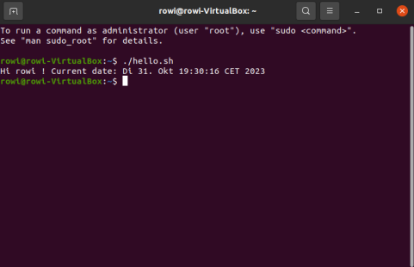

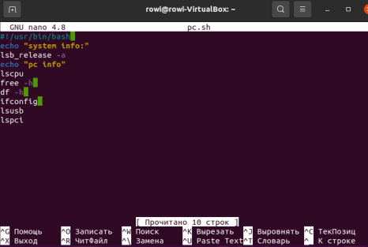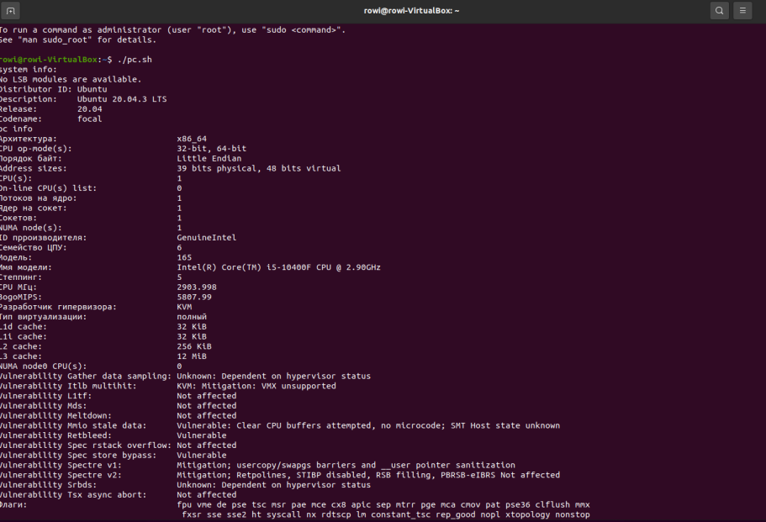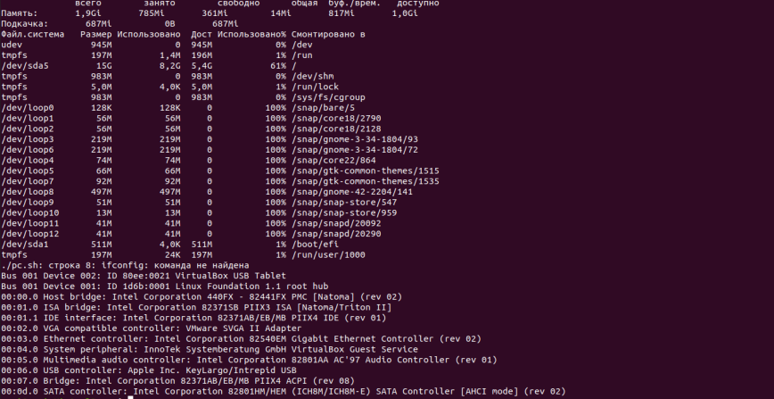

***Готував матеріал студент Нерощин Д.***

***Контрольні запитання***

***1 Processing variables and creating branched and looping scenarios in scripts:***

***Variables in bash scripts are declared and used as follows: variable=value. For example: name="Vasya".***

***To process variables, $variable or ${variable} is used.***

***Branching is performed using if-then-else constructions.***

***Example:***

***if [ condition ]; then***

***# Executes if the condition is true***

***else***

***# Executed if the condition is false***

***fi***

***Loops are created using for, while or until constructs. Example:***

***for variable in element1 element2 ...; do***

***# Executed for each element***

***done***

***while [ condition ]; do***

***# Executes while the condition is true***

***done***

***2 Difference between arch and lscpu commands:***

***arch: Displays the system architecture (eg x86_64).***

***lscpu: Provides detailed CPU information including architecture, number of cores, operating modes, and more.***

***3 The command to obtain information about the state of RAM usage:***

***free: Displays information about free and used memory, including the amount of RAM and swap memory.***

***4 Commands for viewing the status of connected peripheral devices:***

***lsusb: Lists USB devices connected to the system.***

***lspci: Provides information about PCI devices, including graphics cards and other devices.***

***5 Features of the gparted program:***

***GParted is a graphical interface for managing disk partitions in Linux.***

***It allows you to create, edit, delete, move and resize disk partitions.***

***GParted also supports partition formatting and disk renaming operations.***